9/10 Meeting
Date: 9/10/25
Time: 11:00am-12:00pm CDT
Attendees: Juliette Reeder, Jack Hicks, Forrest Tuschhoff, Dr. Chuck Bunting, Dr. Pavithrakrishnan Radhakrishnan Links:
First Wire-Based Log-Periodic (NOT GOOD FOR HIGH POWER)
Second Wire-Based Log-Periodic

Testing existing log-periodic at Richmond Hills:

- In anechoic chamber/outdoors
- Develop measurement system using spectrum analyzer
- Want to learn what design decisions imply for radiation pattern (trade-offs)
- Want to design for appropriate exposure

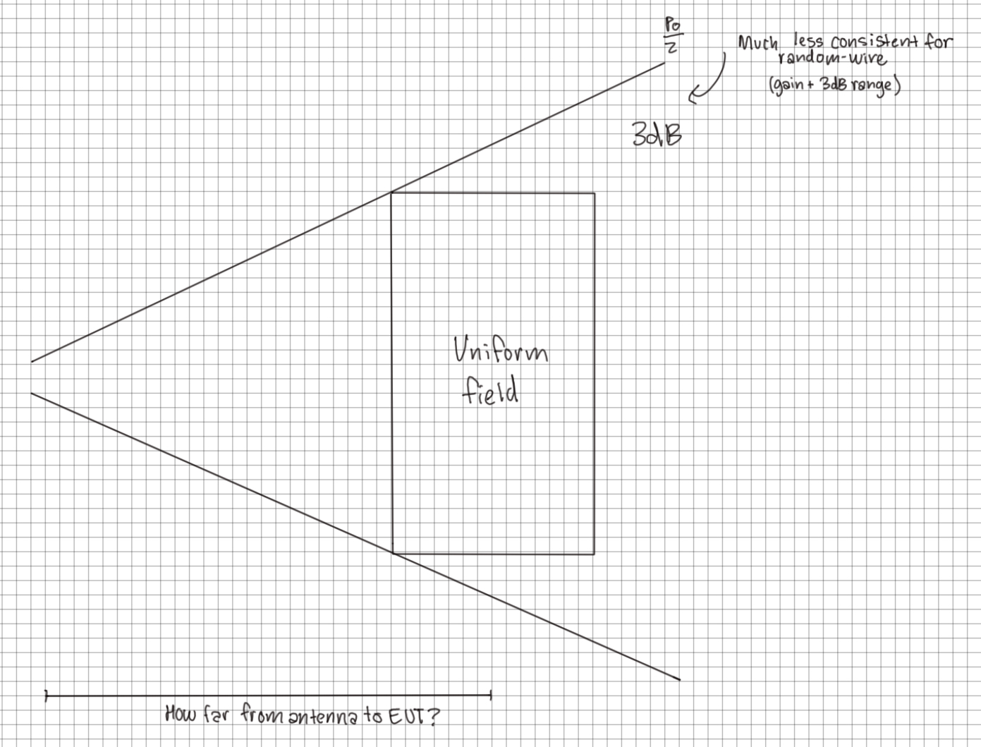

Information about wire based log-periodic:

General concept:
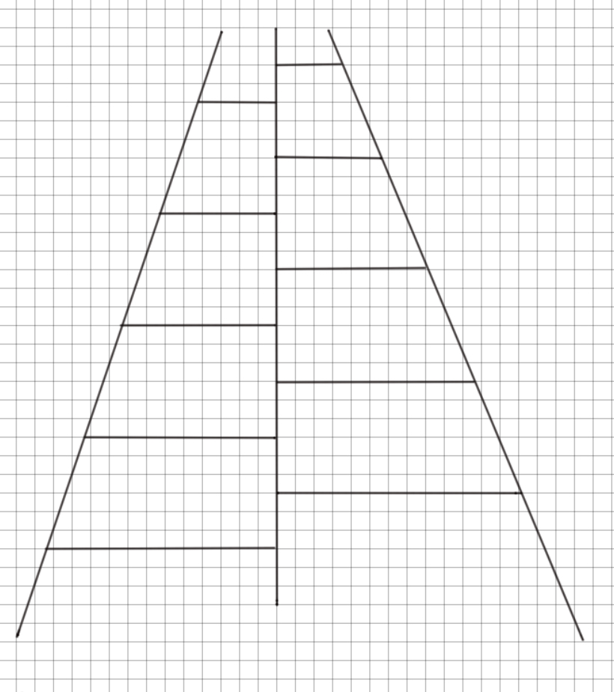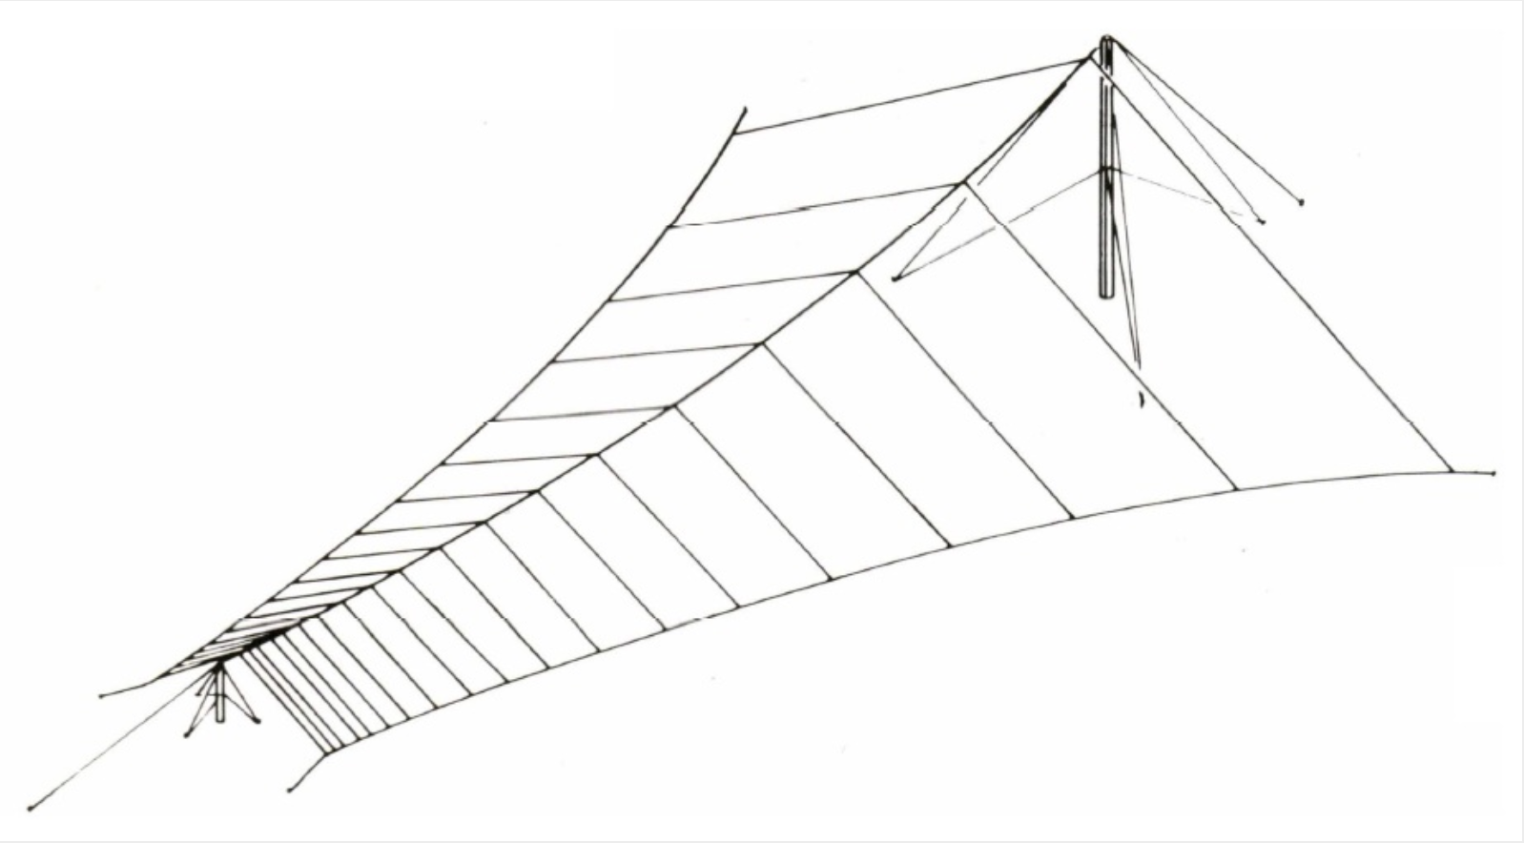

AT LPA HF Log Periodic Antennas:
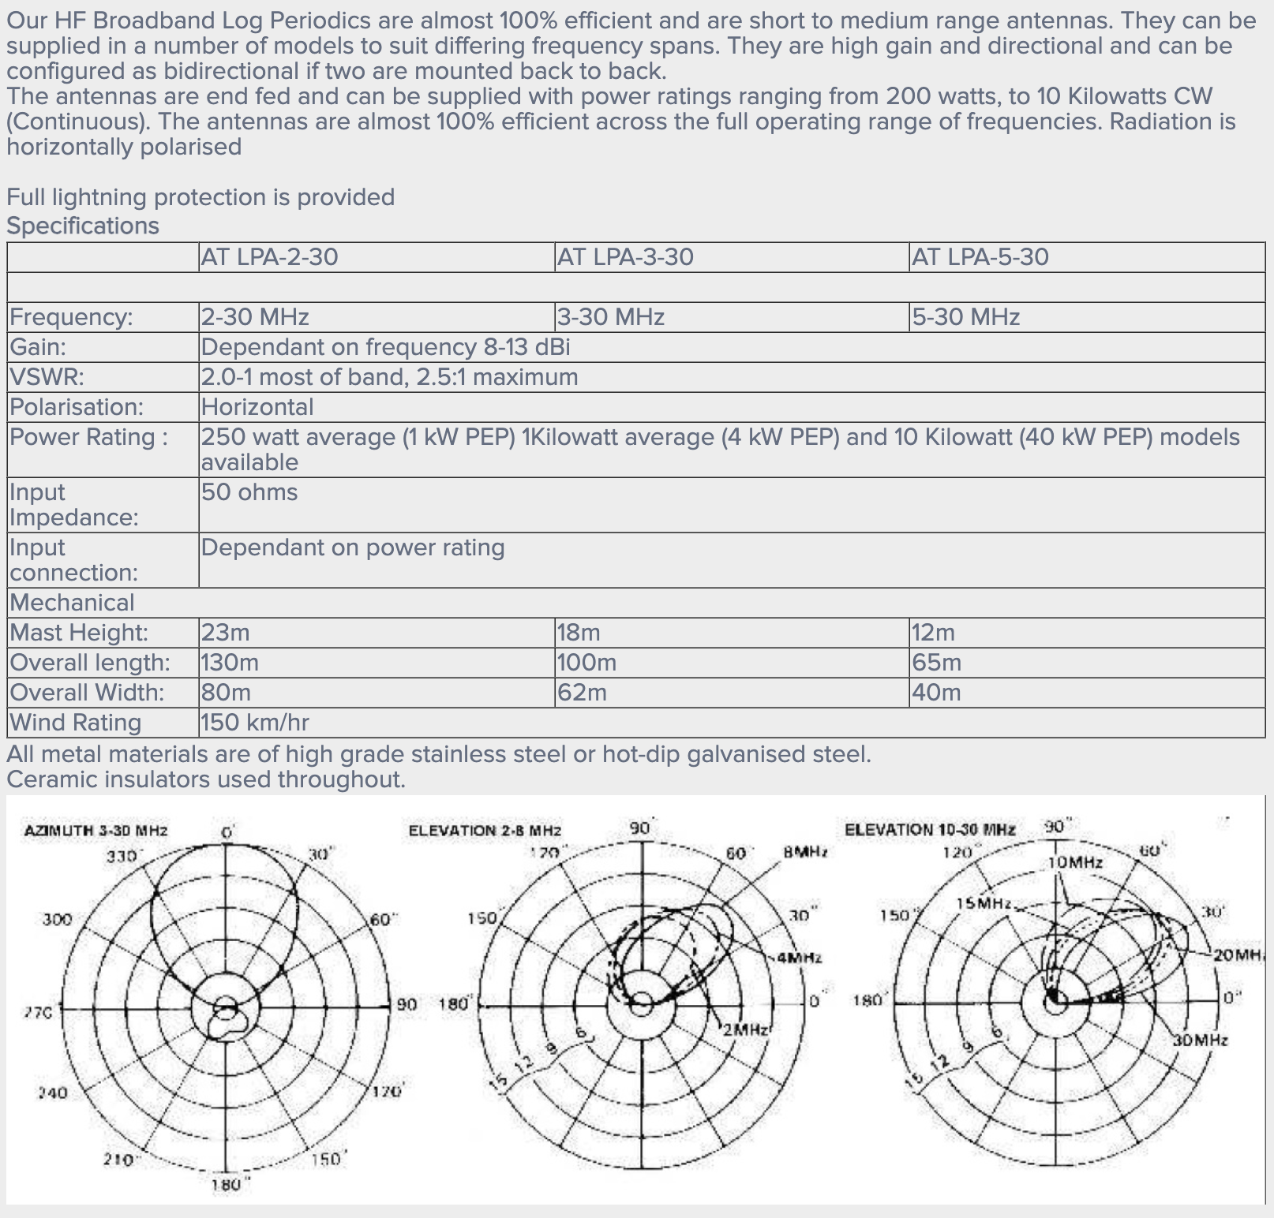

Action items:
- Simulate LPDA in EZNEC
- Simulate Random Wire in EZNEC
- Find the required spec for the E-field strength and area
- Determine procedure for testing existing log-periodic antenna (higher frequency band) using NA
  - In anechoic chamber
  - Outdoors
- Understand common-mode (CM) current
- Determine balun/choke needed for design

